Product Introduction
PROSE Steel perforated panel (Air Floor) is specially designed to allowair flow through the access floor up to the equipment. It is widely used in telecommunications, power electronics, microelectronics, medical and other industries of data room, computer room, Power control room, clean purification workshop and other requirements of anti-static places. It features anti-static interference, reduced fire risk, easy installation and simple maintenance.

Structure
Steel perforated panel (Air Floor) is specially designed to allowair flow through the access floor up to the equipment.
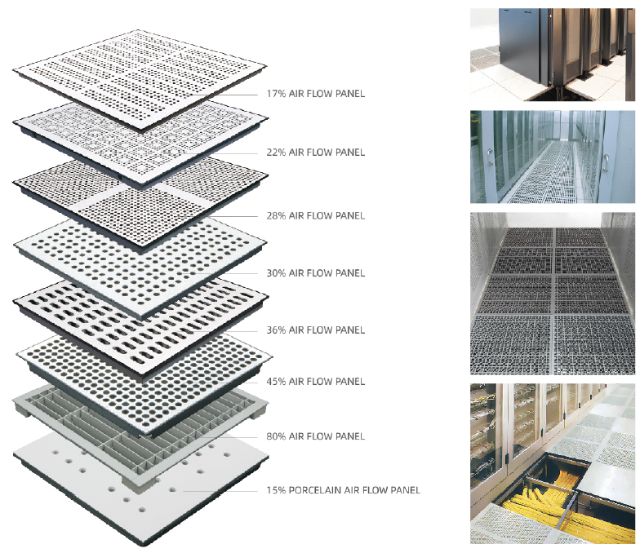

Features/Benefits

- Ventilating: Steel perforated panel (Air Floor) is specially designed to allow air flow through the access floor up to the equipment.
- Easy installation: With a modular design, it can be assembled on the ground without the need for complex construction techniques or large-scale mechanical equipment.
- Simple maintenance: In case of individual damage, local repairs can be carried out without affecting the overall use of the floor. Large-scale maintenance projects have been avoided.

Ordering Information
Category | - | Type | - | Panel Size | - | Finish Floor Height
RFR：Raised Floor |  | ARF: Air floor (Steel perforated panel） | - | 1:600*600mm  2:610*610mm | - | T17: 17% ventilation rate  T22: 22% ventilation rate  T28: 28% ventilation rate  T30: 30% ventilation rate  T36: 36% ventilation rate  T45: 45% ventilation rate

For Example:
Order Number | Description
RFR-ARF-1-T22 | Raised Floor, Air floor,600*600, 22% ventilation rate
RFR-ARF-1-T30 | Raised Floor, Air floor,600*600, 30% ventilation rate
RFR-ARF-1-T45 | Raised Floor, Air floor,600*600, 45% ventilation rate

Accessories

Stringers
Understructure

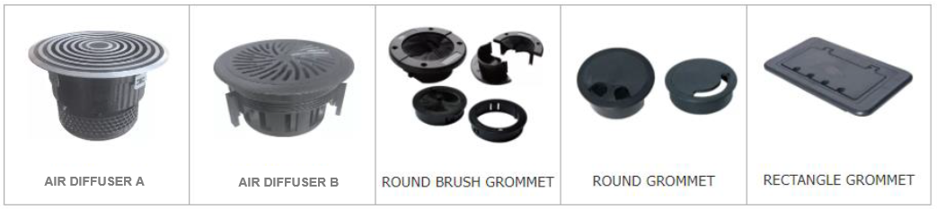
Outlet boxes, grommets, panel lifters, air diffuser, etc.

Ordering Information of accessories
Category | - | Faceplate | - | Type |  | Color
RFR： Raised Floor | - | FC:Flooring accessories | - | DCF:Double cup lifter  SCF:Single cup lifter  ADA:Air diffuser A  ADB:Air diffuser B  RBG:Round brush gromment  RDG:Round gromment  REG:Rectangle gromment  ILG:Integral gromment  SIG:Split integral gromment  OBB: Outlet box B  OBC: Outlet box C | - | default

GLOBAL FOOTPRINT
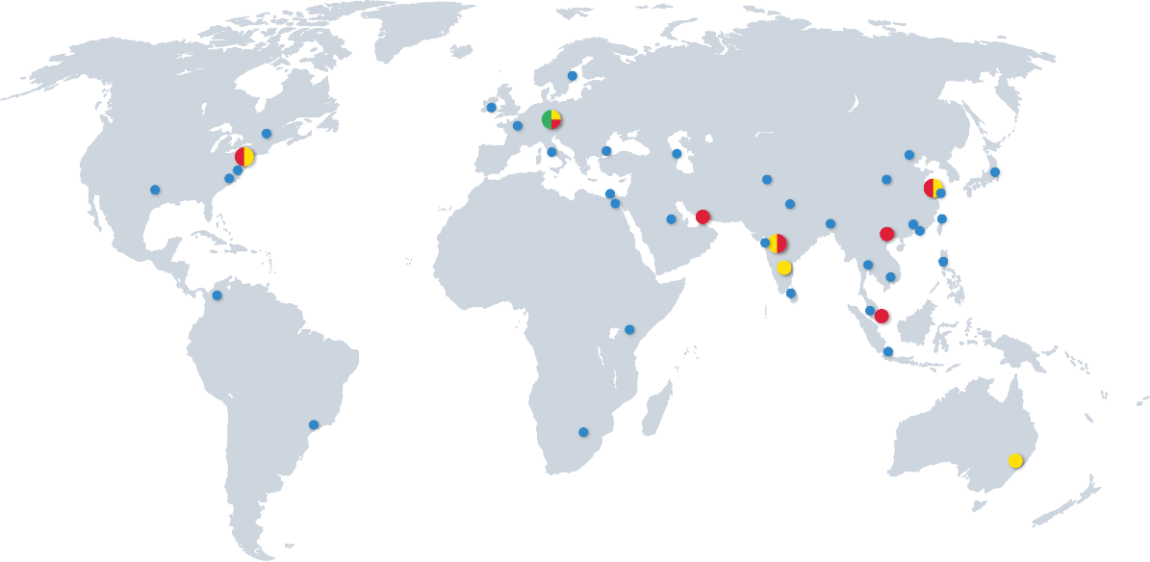

Headquarters | South Asia | South East Asia | East Asia
Donauwörth - Germany  PROSE Technologies GmbH  Add.: Dr.-Friedrich-Drechsler-Straße 14, 86609 Donauwörth, Germany  E-mail: info.eu@Prosetechnologies.com | Mumbai - India  PROSE Technologies India Private Limited  Add.: 403-407, Eco Star, Vishveshwar Nagar, Goregaon East, Mumbai ,India 400063  Tel: +91 22-66453000  E-mail: info.in@prosetechnologies.com  Pune - India  PROSE Technologies India Pvt.Ltd  Add.: A-79, Block-A , Horizon Industrial Parks, Phase II, MIDC Chakan Industrial Area, Khed, Pune , India 410501  Tel: +91 2135-635200  E-mail: info.in@prosetechnologies.com  Bangalore - India  PROSE Technologies India Private Limited  Add.: No.494 East End Main Road, Jayanagar IX Block, Bangalore, India 560069  E-mail: info.in@prosetechnologies.com  New Delhi - India  PROSE Technologies India Pvt.Ltd  Add.: H-3/157, 2nd Floor, Vikas Puri, New Delhi, India 110018  E-mail: info.in@prosetechnologies.com  Dhaka - Bangladesh  PROSE Technologies (Bangladesh) Limited  Add.: House-360 (2nd Floor), Lane-5 (East), Baridhara DOHS, Dhaka-1206, Bangladesh  Tel: +880 1977070130  E-mail: info.bd@prosetechnologies.com  Islamabad - Pakistan  Add.: Unit 514, 5th Floor, ISE Towers, Islamabad, Pakistan  Tel: +92 3335357733  E-mail: info.pk@prosetechnologies.com  Sri Lanka  Tel: +880 1977070130  E-mail: info.lk@prosetechnologies.com | Selangor - Malaysia  PROSE Technology (M) Sdn. Bhd  Add.: Unit 2-1, Level 2, The Podium, Tower 3, UOA Business Park, No 1, Jalan Pengaturcara U1/51a, Seksyen U1, 40150 Shah Alam, Selangor, Malaysia  Tel: +60 126859319  E-mail: info.my@prosetechnologies.com  Bangkok - Thailand  PROSE Technology (Thailand) Co., Ltd  Add.: 349 SJ Infinite I Business Complex,9 Floor, Room 905, Vibhavadi Rangsit Road, Chom Phon Sun-district, Chatuchak District, Bangkok Provice, Thailand  Tel: +66 80 6606630  E-mail: info.th@prosetechnologies.com  Singapore  PROSE Technologies (Singapore) Pte.Ltd  Add.: 10 Anson Road#13-15 International Plaza Singapore 079903  Tel: +6598366793  E-mail: info.sg@prosetechnologies.com  Hanoi - Vietnam  PROSE Technologies (Vietnam) Company Limited  Add.: Floor 15, Vinaconex 9 Building, HH-2 Block, Pham Hung Street, Me Tri Ward, Nam Tu Liem District, Hanoi, Vietnam  Tel: +84 933086498  E-mail: info.vn@prosetechnologies.com  Taguig - Philippines  PROSE Technologies Philippines, Inc.  Add.: Unit 17 19th Floor Highstreet South Corporate Plaza Tower 1, 26th Street corner 9th Avenue, Bonifacio Global City, Taguig City, Philippines  Tel: +63 27572762  E-mail: info.ph@prosetechnologies.com  Jakarta - Indonesia  PT. PROSE Technologies Indonesia  Add.: Plaza Sentral 6th Floor, Jalan Jenderal Sudirman No. 47, Jakarta 12930, Indonesia  Tel: +62 21 57901997  E-mail: info.id@prosetechnologies.com | Suzhou - China  PROSE Technologies (Suzhou) Co.,Ltd  Add.: No. 6, Shen’an Road, DianShanHu, Suzhou, JiangSu, China  E-mail: Info@prosetechnologies.com  Beijing - China  PROSE Technologies (Beijing) Co.,Ltd  E-mail: Info@prosetechnologies.com  Shanghai - China  PROSE Technologies (Shanghai) Co.,Ltd  E-mail: Info@prosetechnologies.com  Dongguan - China  Add.: Room 1506, building 1, No. 1, Yile Road, Songshanhu Park, Dongguan City, Guangdong Province, China  E-mail: Info@prosetechnologies.com  Hongkong - China  PROSE Technologies Company Limited  Add.: Unit B 13/F,Prat Commercial Building, 17-19 Prat Avenue, Tsimshatsui, Kowloon, HongKong, China  Tel:+86 512 86896789 - 2921/2922  E-mail: info.hk@prosetechnologies.com  Taiwan  Tel: +63 2 7572762  E-mail: info.tw@prosetechnologies.com
Western Europe
Dublin - Ireland
PROSE Technologies (Ireland) Limited
Add.: 6th Floor, South Bank House, Barrow Street, Dublin 4 Ireland
E-mail: Info@prosetechnologies.com
Eastern Europe & Central Asia
E-mail: info.eeca@prosetechnologies.com
North America
New Jersey - America
PROSE Technologies LLC
Add.: 550 Clark Drive Budd Lake, NJ 07828, United States of America
Tel: +1 888 840 4066
E-mail: info.us@prosetechnologies.com
Middle East |  |  | Oceania
Dubai - UAE  PROSE Technologies DMCC  Add.: 3702, Mazaya Business Avenue BB2, JLT, Dubai  Tel: +971 4 3999168  E-mail: info.ae@prosetechnologies.com |  |  | New South Wales - Australia  PROSE Technologies (Australia) Pty. Ltd  Add.: 5/13 Boundary Rd, Northmead, NSW 2152, Australia  Tel: +61 2 78055523  E-mail: info.au@prosetechnologies.com
Africa
Nairobi - Kenya
PROSE Technologies Africa (PTY) Ltd
Tel: +254 780440410
E-mail: info.ke@prosetechnologies.com

Gauteng, (Johannesburg) - South Africa
PROSE Technologies Africa (PTY) Ltd
Add.: Building 20, Cambridge Office Park, 5 Bauhina Road, Highveld Techno Park Centurion, Gauteng 0169, South Africa
Mobile: +27 725554840
E-mail: info.za@prosetechnologies.com

