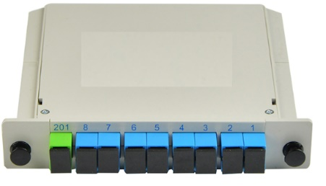
- Small size, high reliability, wide operating wavelength range
- Application for EPON, GPON, FTTx networks
- G657A1 fiber or customer specified
- Splitter ration from 1:2 to 1:64

Part number
PRPLC-S01-XXX-XXX | Planar light wave circuit splitter, insert type
1 2
*1 indicate splitter capacity:102=1X2;202=2X2;104=1X4;204=2X4;108=1X8;208=2X8;116=1X16;216=2X16…
*2 indicate the splitter adapter style: FC=FC; FCA=FC/APC; LC=LC; LCA=LC/APC; SC=SC; SCA=SC/APC…
Performance
Parameters | Specification
Operating wavelength (nm) | 1260-1650
Type | 1X2 | 1X4 | 1X8 | 1X16 | 1X32 | 1X64
Insertion loss (dB) | ≤3.8 | ≤7.1 | ≤10.2 | ≤13.3 | ≤16.5 | ≤19.8
Loss uniformity (dB) | ≤0.3 | ≤0.3 | ≤0.3 | ≤0.5 | ≤0.5 | ≤1.0
PDL (dB) | ≤0.08 | ≤0.08 | ≤0.08 | ≤0.1 | ≤0.1 | ≤0.2
Type | 2X2 | 2X4 | 2X8 | 2X16 | 2X32 | 2X64
Insertion loss (dB) | ≤3.8 | ≤7.1 | ≤10.2 | ≤13.3 | ≤16.5 | ≤20.1
Loss uniformity (dB) | ≤0.5 | ≤0.5 | ≤0.5 | ≤0.8 | ≤0.8 | ≤1.5
PDL (dB) | ≤0.1 | ≤0.1 | ≤0.1 | ≤0.15 | ≤0.15 | ≤0.3
Return loss (dB) | ≥55
Directivity (dB) | ≥55
Wavelength dependent Loss (dB) | ≤1.0
Pigtail length (m) | 1.0m or customer specified
Fiber type | ITU G657A1 or customer specified
Operating temperature (℃) | -40℃ to +85℃
Storage Temperature (℃) | -40℃ to +85℃

While the information has been carefully compiled to the best of our knowledge, nothing is intended as representation or warranty on our part and no statement herein shall be construed as recommendation to infringe existing patents. In the effort to improve our products, we reserve the right to make changes judged to be necessary.

