Product Introduction
Traditional miniaturized data centers have problems such as high maintenance costs, long construction time, and inability to timely understand the operating status. Prose created and innovated smart micro-data center to meet the requirements.
To meet the future deployment requirements of edge computing applications, the KHIPU Smart Microdata Center adopts a modular development concept, The advantage of low cost, suitable for customers to install quickly and put into use in time.
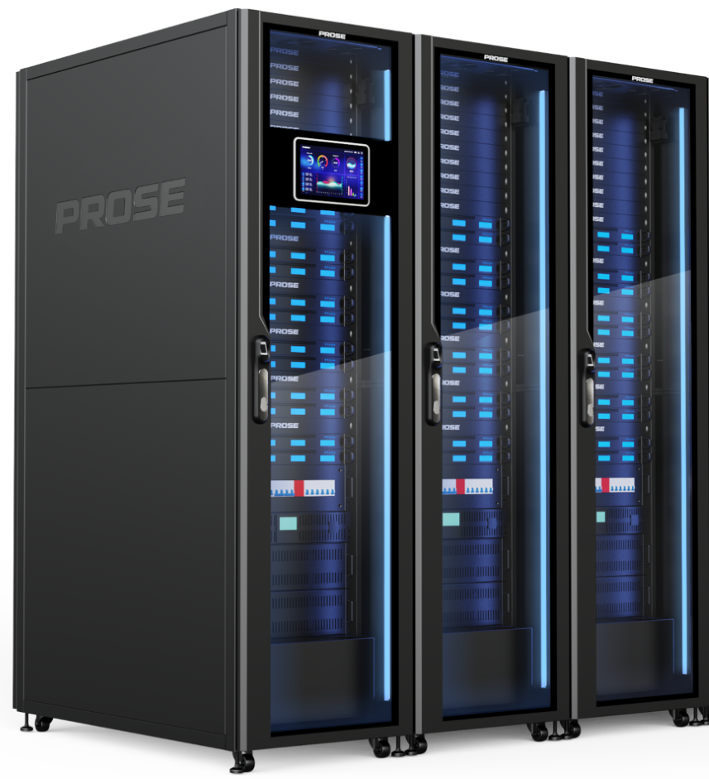
The Smart Microdata Center contains cabinets, power distribution systems, refrigeration systems, cabling systems, while meeting the need for continuous power, to prevent data loss, MDC can be accessed through TCP/IP, Cloud App, etc., so that customers can know the running status of the product in real time. Temperature and humidity monitoring system and air-cooling system provide suitable working environment for customers' products. It also includes face recognition, fingerprint recognition and other authentication to provide data security protection.
Main Feature
- Lower Investment by 25%
- Fast Installation Only 2H
- FC AC Energy Saving 30%
- PUE Less Than 1.26
- System Emergency Response Protection
- Biometrics Authentication
- Cascading Available for Rack
- Saving Room Space 50%
- Quiet Operation Less-than 55dB
- DCIM 24H Cloud O&M
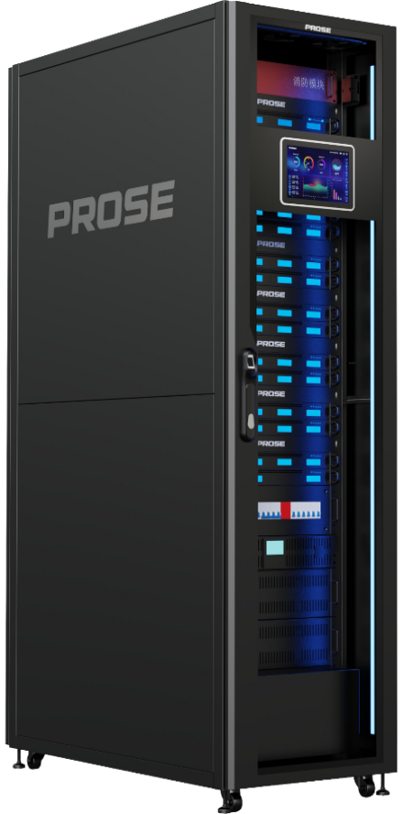
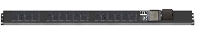
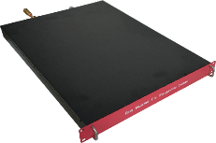
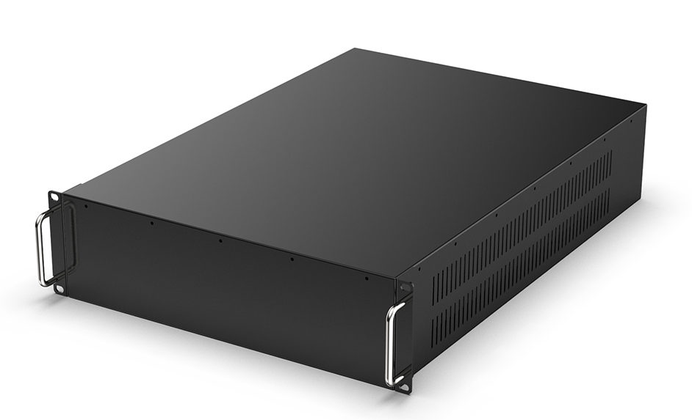
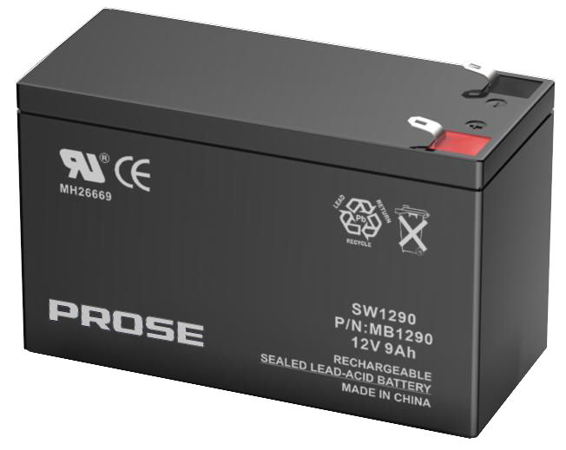
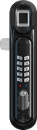
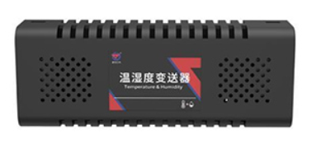
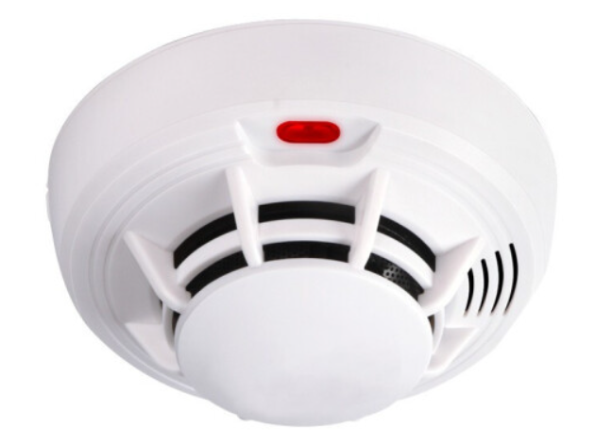
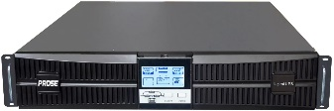
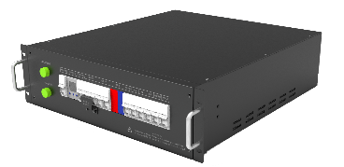
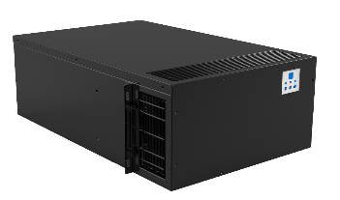
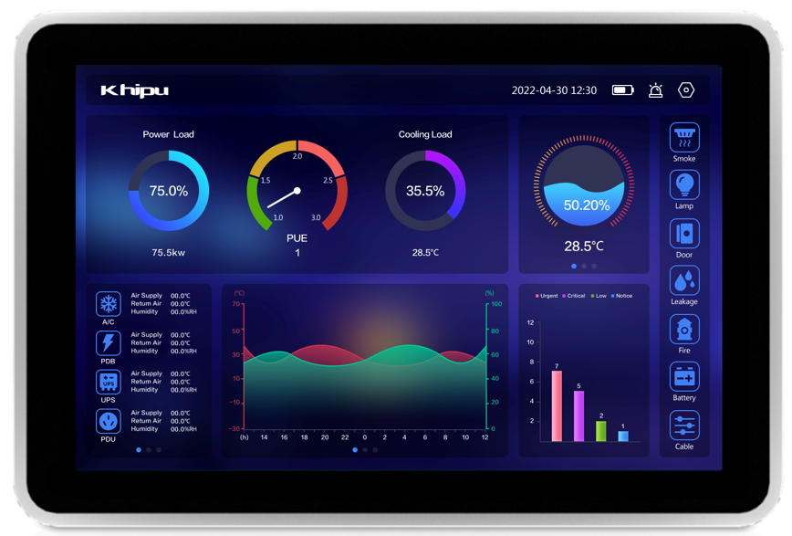
Lead acid / Lithium battery (Battery pack)
Rack –mounted air conditioner
Rack-mounted UPS
Intelligent PDU
Rack-mounted fire suppression module (optional)
Rack-mounted power distribution box
Intelligent lock
Monitor system
Humiture & Smoke sensor

System specification
W600mm* D1200mm * H2050mm, 3 pcs of racks can be put in cascade configuration.
Item | Standard Cabinet
Height Unit (customizable) | 42U
Cabinet Size (mm) | 600 (W) x 1200(D) x 2050(H)
Weight | About 180kg
Static Load | Up to 2200kg
Color | Black or Gray
Structure Composition | Welding framework, cabinet seal design as a whole
Meet Standard | ANSI/EIA RS-310-D, IEC297-2, DIN41491, DIN41494, GB/T3047.2-92
IP Level | IP5X
Display Panel | 10.1” Touch Panel LCD
Display Languages | English / Chinese
LED Lighting | BI-Color (Red & Blue)
Front Door | Toughened glass door with Mechanical lock or fingerprint lock (Support face detector)
Rear Door | Sheet metal door
Safety Standard | RoHS

Power Distribution Box
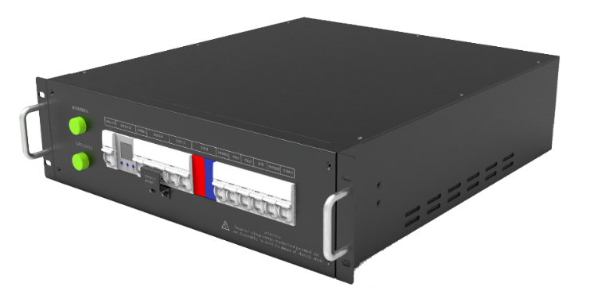

No. | Parameter | Value
1 | Input Rated Voltage(V) | 220VAC
2 | Input Rated Current(A) | 80A
3 | Input Switch | 80A /1P
4 | Output Switch | 2*50A/1P+C50A/2P+D20A/1P*2+16A/1P*4
5 | Lightning Protection Level | Class C lightning protection
6 | Dimensions(mm) | W*D*H，483*500*3U
7 | Color | Black, off-white or according to customer's specification
8 | Ways To Enter and Exit | Top-in and top-out or according to customer's designation
9 | Installation | 19" Rack mounted
10 | Cooling | Natural cooling

Precision Air Conditioning
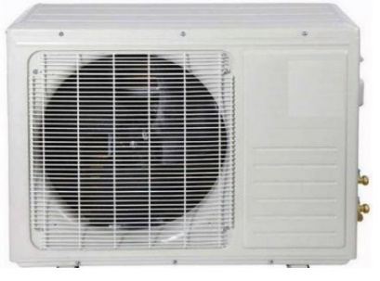
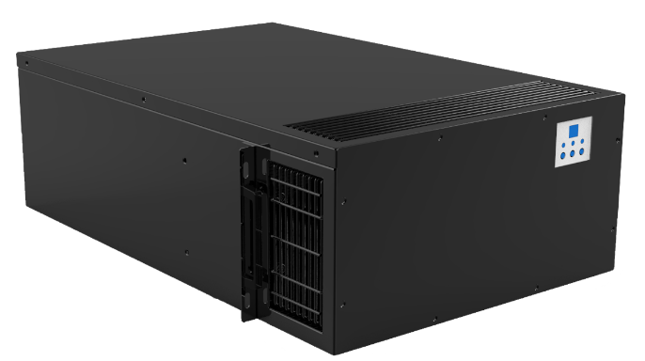

Rack-Type Air Condition Technical Specification
Type |  | 6.5KW
Cooling Capacity | Cooling capacity | 6.7
Cooling Capacity | Sensible heat ratio(SHR) | 98%
Machine air volume (m³/h) |  | 1500
Energy efficiency ratio (EER) |  | 3.5
Compressor | Qty (PC) | 2
Compressor | Type | Enclosed inverter compressor
Fans type |  | Hypokinesis EC centrifugal fan
Expansion valve type |  | Electronic expansion valve
Air supply mode |  | Upper, left, right and three side air supply
Evaporator |  | Copper pipe+ Hydrophilic fin
Freezing medium |  | R410A
Unit standard heating (W) |  | 1000
Power parameter | Input | 220V/50Hz
Power parameter | Electric power supplying parameters FLA(A) | 16.6(30)
Power parameter | Recommended air switch model | 32A
Pipe type | Self-draining pipe (mm) | Inner p16/Outer p21
Pipe type | Strong-Draining pipe (mm) | Inner p5/Outer p7
Pipe type | Refrigerant air pipe (mm) | 15.88
Pipe type | Refrigerant fluid pipe (mm) | 9.52
Indoor machine size (mm) |  | 440*760*352
Indoor machine weight (kg) |  | 35
Outdoor machine size (mm) |  | 810*580*280
Outdoor machine weight (kg) |  | 35
Connect the inner and outer machines with copper pipes and cables |  | 5m

UPS（Uninterrupted Power Supply）
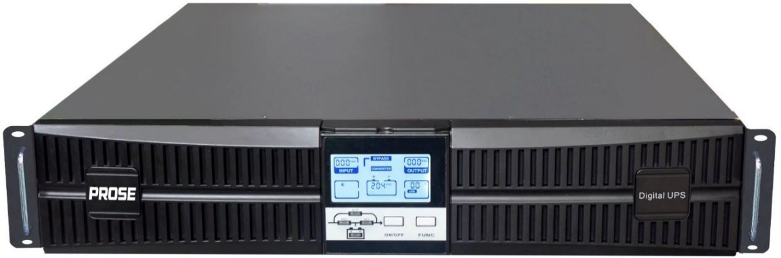

Mode |  | UPS-RM20101-11
Power capacity |  | 10kVA/10000W
Input | Voltage range | 110-288VAC(220/230/240VAC)
Input | Frequency | 40-70Hz
Input | Power factor | ≥0.99
Output | Voltage range | 220VAC±1%
Output | Frequency | 50/60Hz
Output | Wave form | Sinusoidal wave
Output | Power factor | 1
Output | Overload capacity (Inverter mode) | 110% : Bypass after 10 minutes; 130% : Bypass is cut after 1 minute; 150% : Bypass after 30 seconds, shut down after 1 minute
Output | Peak value ratio | 3：1
Efficiency |  | Main road mode 95%；  ECO Mode 98%
Battery | Mode | Depends on the external battery
Battery | Qty | Depends on the external battery
Battery | Maximum charging current | 5A
Battery | Dc voltage | 192-288VDC
Communication mode |  | RS 232、SNMP
Option |  | Removable dry contact card, maintenance switch, parallel card, battery pack, USB, SNMP, RS 485 interface
Bypass |  | Standard configuration
Environment | Temperature | 0-40℃
Environment | Humidness | 0-95%
Size |  | 440*550*86
W*D*H(mm) |  | 440*550*86
Special specification |  | Depth of the server cabinet ≥1 m
Weight (kg) |  | 18

Dynamic Environment Monitoring System
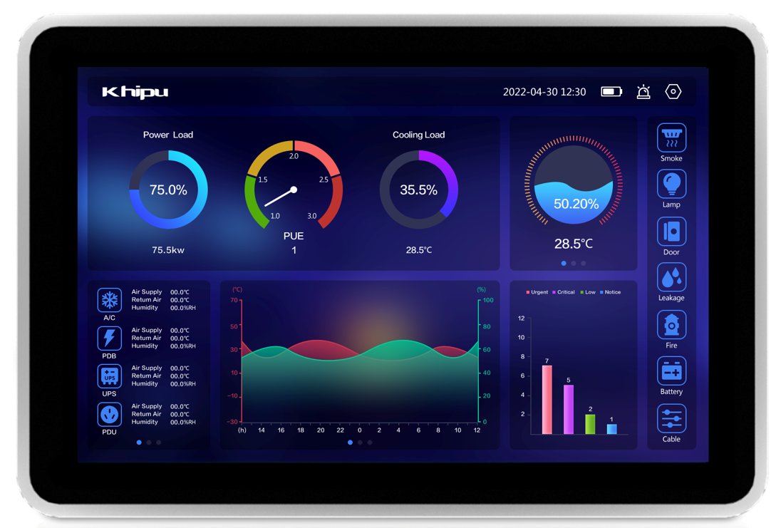

Item | Technical Specification
CPU | ARM Cortex A9 Quad-core, Max Frequency 1.2GHz
Operating System | Android 5.1
Memory | DDR3L 2GB
Flash Rom | 8GB eMMC Flash
Standard Serial Port | 2 Ports RS232
Standard Serial Port | 2 Ports RS485
Debug Port | 1 Port Micro USB
Digital Input Port | 2 Ports DI
Digital Output Port | 2 Ports DO(for relay control)
USB Port | 3 Ports (1 Port USB Host, 2 Ports USB Device)
Debug Port | 1 Port Micro USB
Output Supply | 6 Ports 12V/1A
Wireless | Reserved for 3G, 4G and Wi-Fi module expansion slot
Ethernet | 1 Ports RJ45 10M/100M/1000M
Operating Voltage | 12V DC
Max Power | 35W
Size | 266 mm× 182 mm× 48.5 mm
ESD Level | Contact: 6KV; Air: 8KV
MTBF | ≥100000H
Operating Temperature | -20~60℃
Operating Humidity | 10%~90%RH

Battery Pack
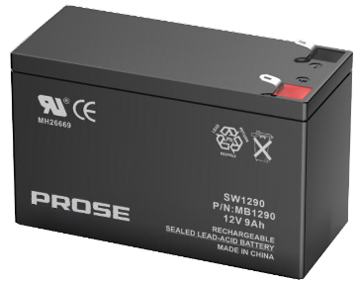

Battery Pack Valve Regulated Lead Acid Battery (VRLA)

Cabinet Power | Backup Time | Battery Pack Type | Battery Pack QTY
10KVA (9kw) | 15 mins | 5U Battery Pack (8pcs 38AH) | 2set
PDU（Power Distribution Unit）

Item | Specification
Rated current | 16A
Rated voltage | 220VAC 50/60Hz
Output ports | 24*C13
Max power | 5KW
Outline size | 1217(Adjustable length) x 44 x 44 mm
Installation method | Horizontal/Vertical installation
Safety certification | UL/CE/CCC
Function | Lightning protection, intelligent monitoring, and general circuit breaker are optional

Integrative Door Lock
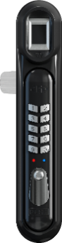

Type of Device | Specification
Rated operating voltage | DC12V
Working current | Static standby: <250mA  Dynamic Electronically Controlled Unlocking: <500mA
Communication mode | RS485，9600bit/s
Service life | Above 500,000 times
Color | Black
Operating temperature/humidity | -20℃ ~50℃ / 20～90%
Storage temperature/humidity | -30℃ ~60℃ / 20～90%
IP rate | IP65
3 unlock modes | Remote unlocking by monitoring host control software  Authorized card writes the card number and swipes card to unlock  Mechanicals unlock
Access control authorization | 500 to 5000 fingerprints
Authorized entrance number | Up to 5000
Software authorization | Authorized by system software through network Communication
Event records | Up to 1120 history records
Function | Mechanical unlocking, password of the IC card, fingerprint and so on, can be paired with
Communication interface | RS485 networking real-time monitoring, door status, handle status, real-time clock function
Server-Rack Automatic Fire Suppression System (Option)
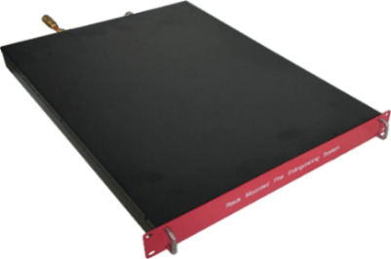

Type Of Device | Server-Rack FireSuppression Unit
Model number | JJQR-Q-W/C-4/1.2-WL/ZZ
Control the number of cabinets | Less than 4 set
Size | 483(W)*500(D)*1U(H)mm
Fire extinguishing agent | HFC-ea.
Storage pressure(20℃) | 1.2MPa
Injection time | ≤10S
Action temperature of fire detecting tube | 170 ℃ ±10 ℃
Max. Length of Fire detection tube | 5m for each cabinet

Product Configuration
PN | Description | Picture
MDC-5331-1122-C141-1351 | Triplex cabinet KHIPU MDC:  3 set Close Cabinet 42U: 600mm x 1200mm x 2050mm  1 set UPS capacity is 10KVA 1-phase  15-minute Battery Pack  1 set Panel Distribution Box 1 Phase  2 set Precision Air Cooling 6.5 KW  3 pcs Smoke sensor  3 pcs Temperature & Humidity Sensor  3 pcs PDU 24 outlet PDU, 16A, IEC 320 C13  3 pcs Keypad, Fingerprint lock  3 set Automatic fire suppression system  1 set Master Environmental Monitoring System bundling with Touch Panel LCD for Dashboard

Note: The above product information is the default information and can be customized according to customers.

GLOBAL FOOTPRINT
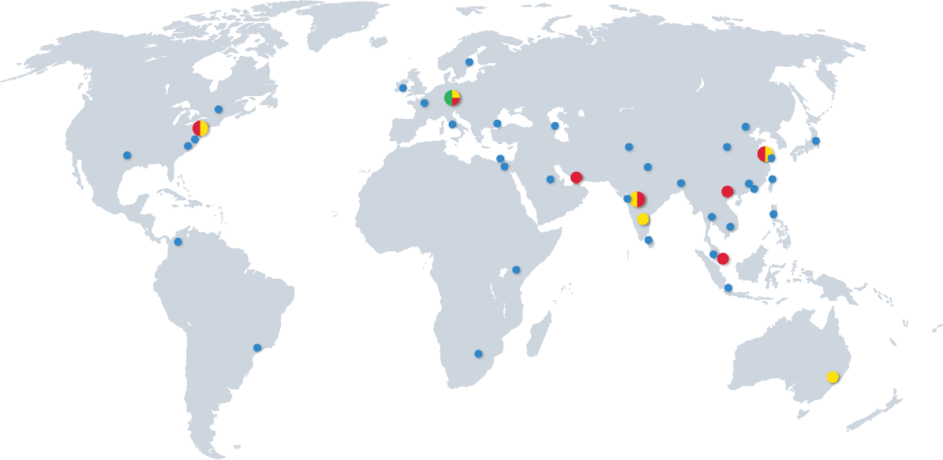

Headquarters | South Asia | South East Asia | East Asia
Donauwörth - Germany  PROSE Technologies GmbH  Add.: Dr.-Friedrich-Drechsler-Straße 14, 86609 Donauwörth, Germany  E-mail: info.eu@Prosetechnologies.com | Mumbai - India  PROSE Technologies India Private Limited  Add.: 403-407, Eco Star, Vishveshwar Nagar, Goregaon East, Mumbai ,India 400063  Tel: +91 22-66453000  E-mail: info.in@prosetechnologies.com  Pune - India  PROSE Technologies India Pvt.Ltd  Add.: A-79, Block-A , Horizon Industrial Parks, Phase II, MIDC Chakan Industrial Area, Khed, Pune , India 410501  Tel: +91 2135-635200  E-mail: info.in@prosetechnologies.com  Bangalore - India  PROSE Technologies India Private Limited  Add.: No.494 East End Main Road, Jayanagar IX Block, Bangalore, India 560069  E-mail: info.in@prosetechnologies.com  New Delhi - India  PROSE Technologies India Pvt.Ltd  Add.: H-3/157, 2nd Floor, Vikas Puri, New Delhi, India 110018  E-mail: info.in@prosetechnologies.com  Dhaka - Bangladesh  PROSE Technologies (Bangladesh) Limited  Add.: House-360 (2nd Floor), Lane-5 (East), Baridhara DOHS, Dhaka-1206, Bangladesh  Tel: +880 1977070130  E-mail: info.bd@prosetechnologies.com  Islamabad - Pakistan  Add.: Unit 514, 5th Floor, ISE Towers, Islamabad, Pakistan  Tel: +92 3335357733  E-mail: info.pk@prosetechnologies.com  Sri Lanka  Tel: +880 1977070130  E-mail: info.lk@prosetechnologies.com | Selangor - Malaysia  PROSE Technology (M) Sdn. Bhd  Add.: Unit 2-1, Level 2, The Podium, Tower 3, UOA Business Park, No 1, Jalan Pengaturcara U1/51a, Seksyen U1, 40150 Shah Alam, Selangor, Malaysia  Tel: +60 126859319  E-mail: info.my@prosetechnologies.com  Bangkok - Thailand  PROSE Technology (Thailand) Co., Ltd  Add.: 349 SJ Infinite I Business Complex,9 Floor, Room 905, Vibhavadi Rangsit Road, Chom Phon Sun-district, Chatuchak District, Bangkok Provice, Thailand  Tel: +66 80 6606630  E-mail: info.th@prosetechnologies.com  Singapore  PROSE Technologies (Singapore) Pte.Ltd  Add.: 10 Anson Road#13-15 International Plaza Singapore 079903  Tel: +6598366793  E-mail: info.sg@prosetechnologies.com  Hanoi - Vietnam  PROSE Technologies (Vietnam) Company Limited  Add.: Floor 15, Vinaconex 9 Building, HH-2 Block, Pham Hung Street, Me Tri Ward, Nam Tu Liem District, Hanoi, Vietnam  Tel: +84 933086498  E-mail: info.vn@prosetechnologies.com  Taguig - Philippines  PROSE Technologies Philippines, Inc.  Add.: Unit 17 19th Floor Highstreet South Corporate Plaza Tower 1, 26th Street corner 9th Avenue, Bonifacio Global City, Taguig City, Philippines  Tel: +63 27572762  E-mail: info.ph@prosetechnologies.com  Jakarta - Indonesia  PT. PROSE Technologies Indonesia  Add.: Plaza Sentral 6th Floor, Jalan Jenderal Sudirman No. 47, Jakarta 12930, Indonesia  Tel: +62 21 57901997  E-mail: info.id@prosetechnologies.com | Suzhou - China  PROSE Technologies (Suzhou) Co.,Ltd  Add.: No. 6, Shen’an Road, DianShanHu, Suzhou, JiangSu, China  E-mail: Info@prosetechnologies.com  Beijing - China  PROSE Technologies (Beijing) Co.,Ltd  E-mail: Info@prosetechnologies.com  Shanghai - China  PROSE Technologies (Shanghai) Co.,Ltd  E-mail: Info@prosetechnologies.com  Dongguan - China  Add.: Room 1506, building 1, No. 1, Yile Road, Songshanhu Park, Dongguan City, Guangdong Province, China  E-mail: Info@prosetechnologies.com  Hongkong - China  PROSE Technologies Company Limited  Add.: Unit B 13/F,Prat Commercial Building, 17-19 Prat Avenue, Tsimshatsui, Kowloon, HongKong, China  Tel:+86 512 86896789 - 2921/2922  E-mail: info.hk@prosetechnologies.com  Taiwan  Tel: +63 2 7572762  E-mail: info.tw@prosetechnologies.com
Western Europe
Dublin - Ireland
PROSE Technologies (Ireland) Limited
Add.: 6th Floor, South Bank House, Barrow Street, Dublin 4 Ireland
E-mail: Info@prosetechnologies.com
Eastern Europe & Central Asia
E-mail: info.eeca@prosetechnologies.com
North America
New Jersey - America
PROSE Technologies LLC
Add.: 550 Clark Drive Budd Lake, NJ 07828, United States of America
Tel: +1 888 840 4066
E-mail: info.us@prosetechnologies.com
Middle East |  |  | Oceania
Dubai - UAE  PROSE Technologies DMCC  Add.: 3702, Mazaya Business Avenue BB2, JLT, Dubai  Tel: +971 4 3999168  E-mail: info.ae@prosetechnologies.com |  |  | New South Wales - Australia  PROSE Technologies (Australia) Pty. Ltd  Add.: 5/13 Boundary Rd, Northmead, NSW 2152, Australia  Tel: +61 2 78055523  E-mail: info.au@prosetechnologies.com
Africa
Nairobi - Kenya
PROSE Technologies Africa (PTY) Ltd
Tel: +254 780440410
E-mail: info.ke@prosetechnologies.com

Gauteng, (Johannesburg) - South Africa
PROSE Technologies Africa (PTY) Ltd
Add.: Building 20, Cambridge Office Park, 5 Bauhina Road, Highveld Techno Park Centurion, Gauteng 0169, South Africa
Mobile: +27 725554840
E-mail: info.za@prosetechnologies.com

